JENKINS-CHALLENGE
Importance of Jenkins Pipeline
A Jenkins pipeline is a structured way to automate CI/CD tasks from source code to quality checks and notifications.
Why Jenkins Pipeline is Important
1. Automation
Automatically pulls code, checks quality, and sends alerts without manual effort.
- Consistency
Every build follows the same steps, reducing human errors.
- Faster Feedback
Developers get quick feedback on code quality and build status.
- Early Bug Detection
Integrating SonarQube helps detect bugs, vulnerabilities, and code smells early.
- Improved Collaboration
Slack notifications instantly inform the team about build results.
- Scalability
Pipelines can be extended later to include Maven, Docker, deployment, etc.
- Traceability
Each stage (clone, scan, notify) is logged and auditable.
Importance of Tools Used
- Jenkins (CI Tool)
Role: Orchestrator of the pipeline Why Jenkins is important:
- Automates the CI workflow
- Supports thousands of plugins
- Easy integration with Git, SonarQube, Slack
- Open-source and widely used in industry

- Git & GitHub
Role: Source Code Management Importance:
- Centralized code repository
- Version control and history tracking
- Enables collaboration among developers
- Jenkins pulls code directly from GitHub

- SonarQube
Role: Static Code Quality & Security Analysis
Why SonarQube is important:
- Detects bugs, vulnerabilities, and code smells
- Enforces coding standards
- Improves maintainability and security
- Helps maintain high code quality before deployment

- PostgreSQL
Role: SonarQube Backend Database
Importance:
- Officially supported database for SonarQube
- Reliable and high-performance
- Stores metrics, issues, quality gates, and history
- Better stability compared to deprecated MySQL support

- Slack
Role: Notification & Collaboration Tool
Why Slack integration is useful:
- Sends real-time build and scan alerts
- Improves team communication
- Reduces dependency on Jenkins UI
- Helps in faster issue resolution

- Docker (Used during troubleshooting)
Role: Alternative deployment option
Importance:
- Provides quick setup
- Avoids dependency conflicts
- Helps compare containerized vs traditional setup
- Useful for learning and fallback deployment

- Java (JDK 17)
Role: Runtime for Jenkins & SonarQube
Importance:
- Required for Jenkins and SonarQube execution
- Correct Java version prevents compatibility issues
- Ensures Elasticsearch and Sonar services run properly
Overall Architecture Importance
Developer → GitHub → Jenkins Pipeline
↓
SonarQube Analysis
↓
Slack Notification
- Ensures code quality
- Ensures automation
- Ensures team visibility
Challenge Task title:
Use the below code and implement our CICD stages.
- Source Code: https://github.com/betawins/hiring-app.git
o Repository contains the application code for the hiring app.
  - Create one Declarative pipeline job
  - Create one Scripted pipeline job
  - Create one multi stage pipeline job
  - Create one parallel stage pipeline job Jenkins Official

Documentation:
Go to master Jenkins instance start the instance
After starting the instance go to inside instance connect with ssh
After connecting start Jenkins server
And then open Jenkins GUI server
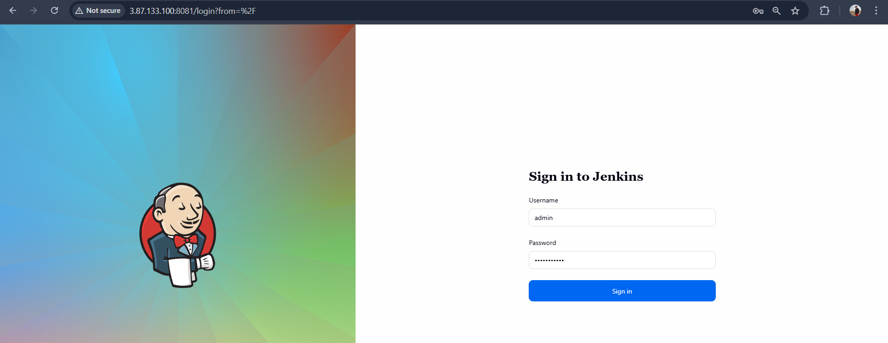
Go to nexus instance and open instance and connect with ssh -i
After connecting start nexus and open in browser with 8081 port number
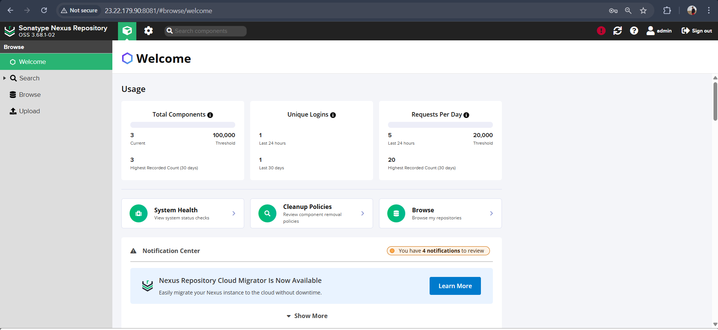
Go to sonarqube server open and connect
Start docker and start sonarqube
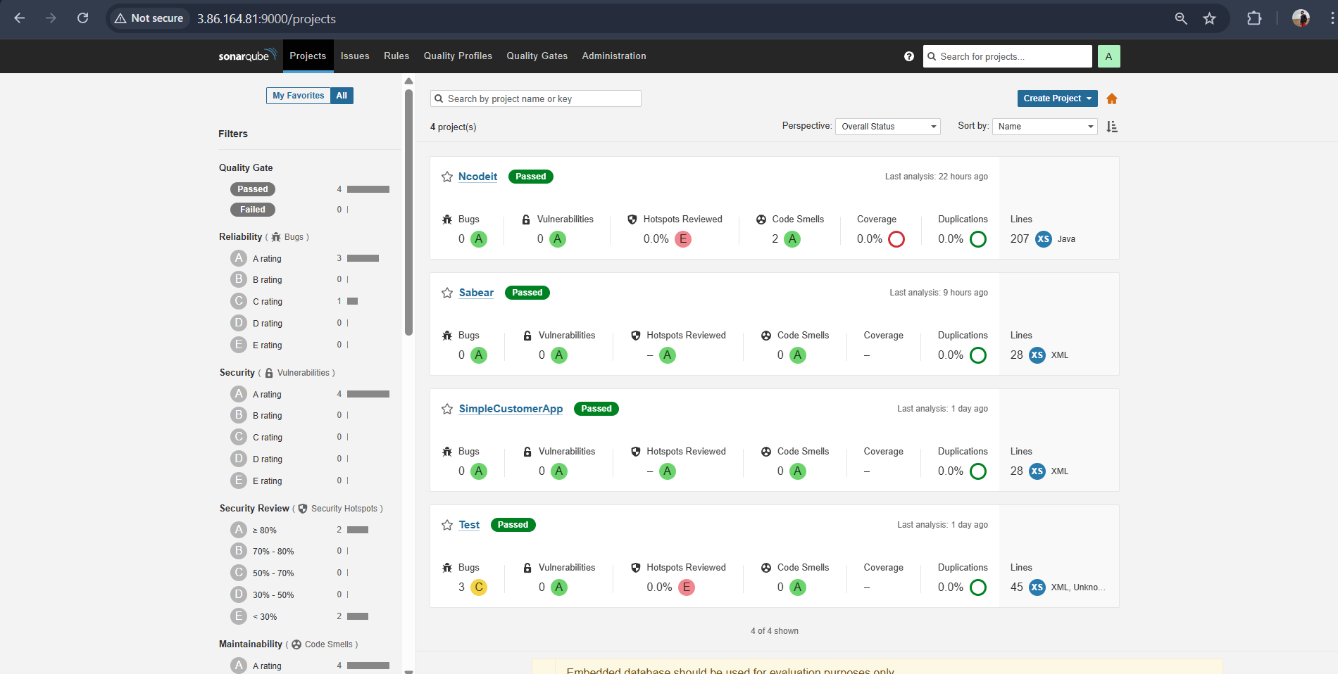

1.Create one Declarative pipeline job
Create new job for declarative job with selecting pipeline
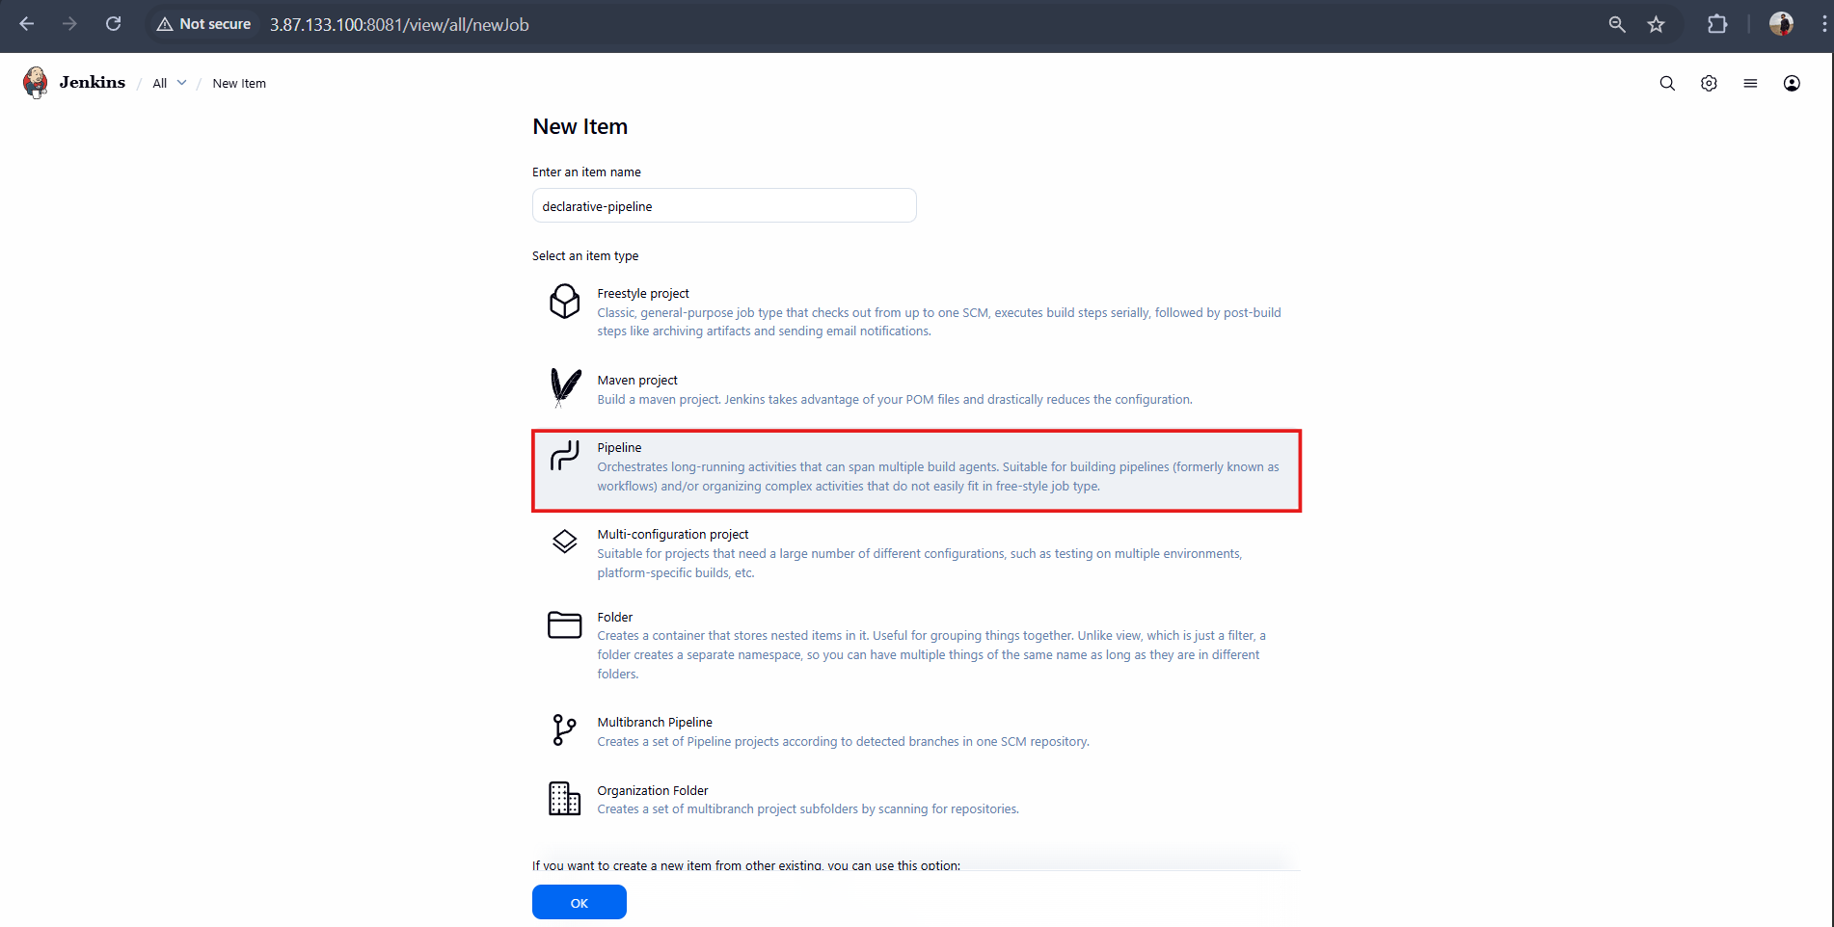
Pipeline which I have used:
pipeline {
agent any

tools {
maven 'MVN_HOME'
}

environment {
SONAR_PROJECT_KEY = 'Sabear'
SONAR_PROJECT_NAME = 'Sabear'

SONARQUBE_URL = 'http://3.86.164.81:9000'

NEXUS_URL = '23.22.179.90:8081'
NEXUS_REPO = 'hiring-app-snapshot'
NEXUS_CRED = 'nexus_keygen'

TOMCAT_URL = 'http://54.227.155.175:8080'
TOMCAT_CONTEXT = 'simplecustomerapp'
TOMCAT_CRED = 'tomcat_credentials'

SLACK_CHANNEL = '#jenkins-integration'
}

stages {

stage('Notify Build Started') {
steps {
slackSend(
channel: "${SLACK_CHANNEL}",
color: '#439FE0',
message: "*BUILD STARTED*\nJob: ${env.JOB_NAME}\nBuild: #${env.BUILD_NUMBER}\n${env.BUILD_URL}"
)
}
}

stage('Git Clone') {
steps {
git branch: 'main',
url: 'https://github.com/betawins/hiring-app.git'
}
}

stage('Maven Build') {
steps {
sh 'mvn clean package -DskipTests'
}
}

stage('SonarQube Analysis') {
options {
timeout(time: 10, unit: 'MINUTES')
}
steps {
withSonarQubeEnv('sonarqube-server') {
sh '''
mvn org.sonarsource.scanner.maven:sonar-maven-plugin:5.5.0.6356:sonar \
-Dsonar.projectKey=Sabear \
-Dsonar.projectName=Sabear
'''
}
}
}

stage('Upload WAR to Nexus') {
steps {
withCredentials([usernamePassword(
credentialsId: "${NEXUS_CRED}",
usernameVariable: 'NEXUS_USER',
passwordVariable: 'NEXUS_PASS'
)]) {
sh '''
WAR_FILE=$(ls target/*.war | head -n 1)

curl -u $NEXUS_USER:$NEXUS_PASS \
--upload-file $WAR_FILE \
http://${NEXUS_URL}/repository/${NEXUS_REPO}/com/javahome/hiring/${BUILD_NUMBER}/hiring-${BUILD_NUMBER}.war
'''
}
}
}

stage('Deploy to Tomcat') {
steps {
withCredentials([usernamePassword(
credentialsId: "${TOMCAT_CRED}",
usernameVariable: 'TOMCAT_USER',
passwordVariable: 'TOMCAT_PASS'
)]) {
sh '''
WAR_FILE=$(ls target/*.war | head -n 1)

curl -u $TOMCAT_USER:$TOMCAT_PASS \
-T $WAR_FILE \
"${TOMCAT_URL}/manager/text/deploy?path=/${TOMCAT_CONTEXT}&update=true"
'''
}
}
}
}

post {
success {
slackSend(
channel: "${SLACK_CHANNEL}",
color: 'good',
message: "*BUILD SUCCESS*\nJob: ${env.JOB_NAME}\nBuild: #${env.BUILD_NUMBER}\n${env.BUILD_URL}"
)
}

failure {
slackSend(
channel: "${SLACK_CHANNEL}",
color: 'danger',
message: "*BUILD FAILED*\nJob: ${env.JOB_NAME}\nBuild: #${env.BUILD_NUMBER}\n${env.BUILD_URL}"
)
}
}
}
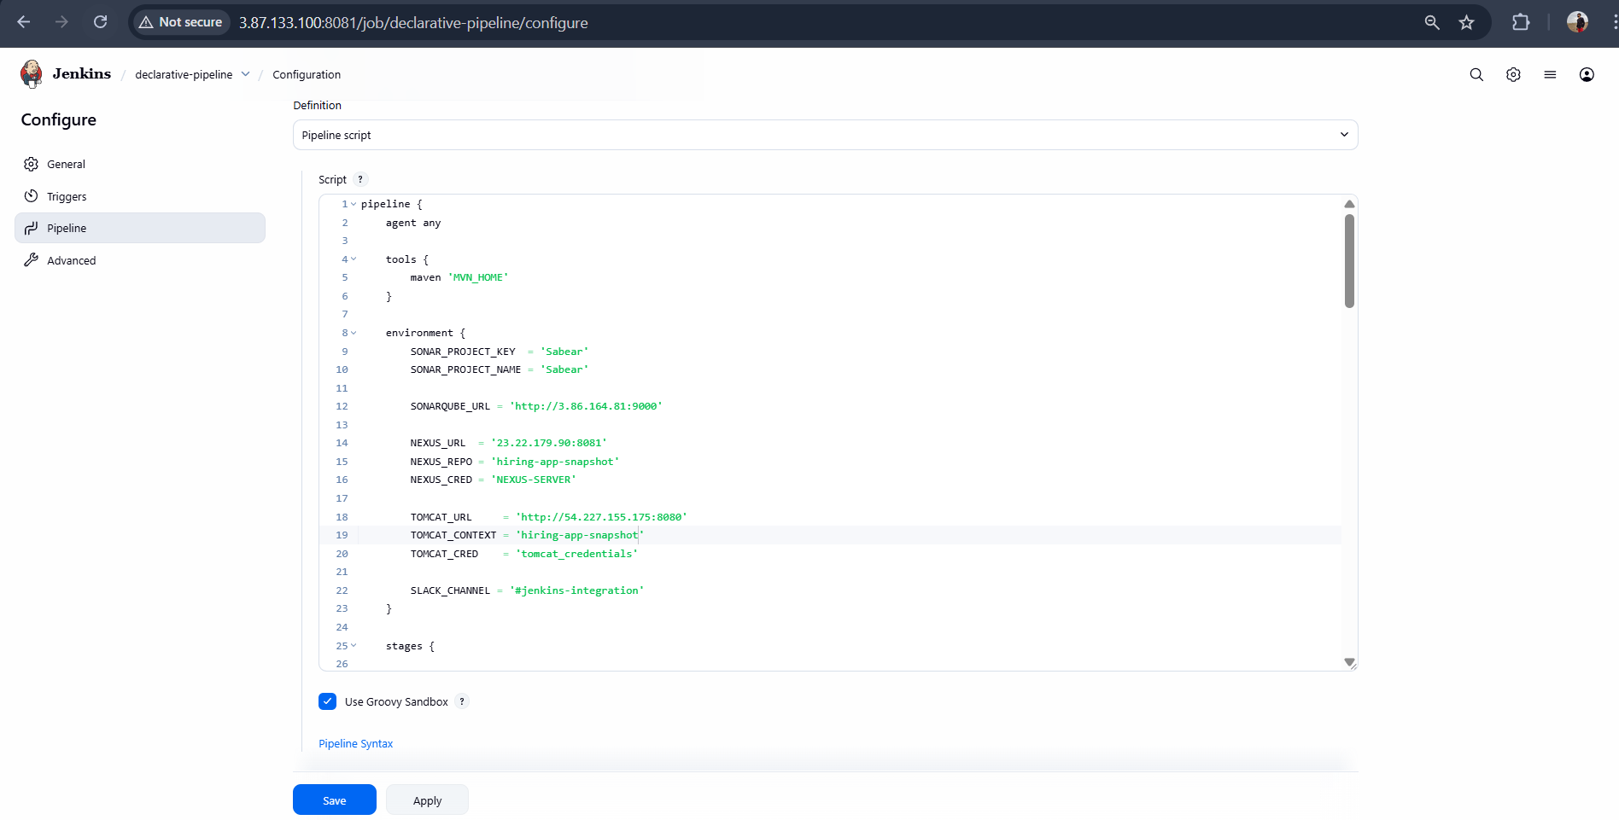
Build was executed successfully
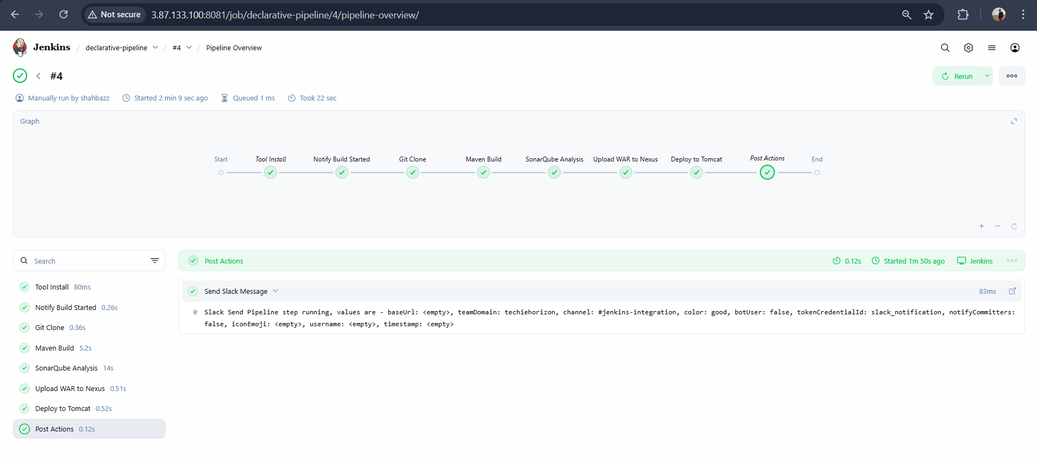
Slack Notification:
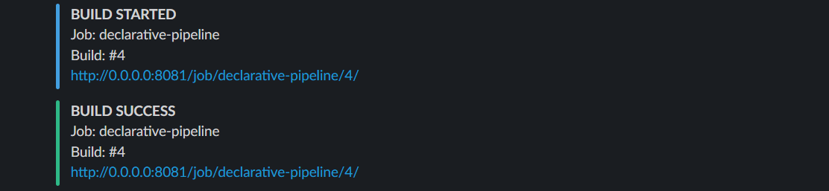

2.Create one Scripted pipeline job
Go to dashboard and create a new job for scripted
Job new Item scripted-pipeline
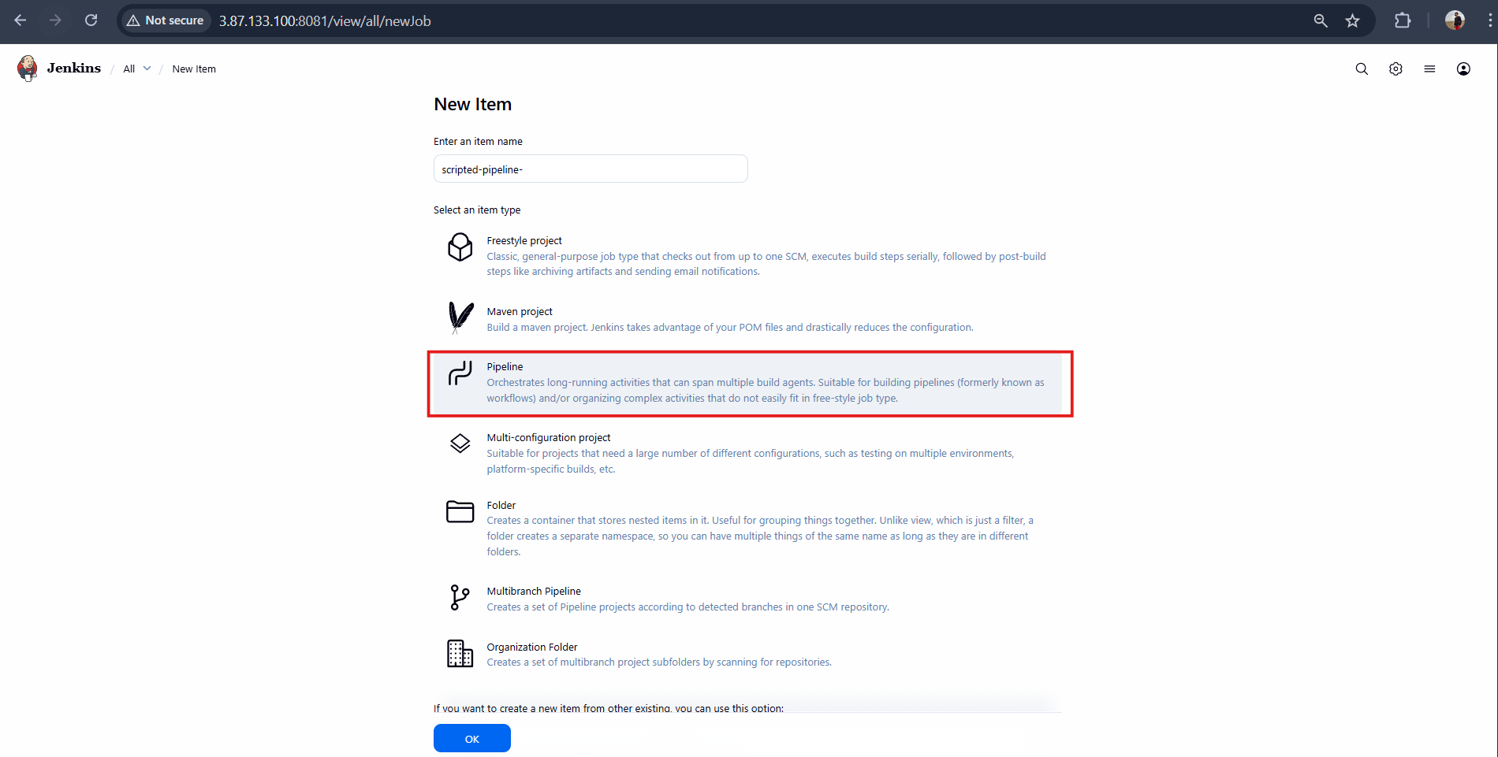
Pipeline which I have used:
node {

// Equivalent of: tools { maven 'MVN_HOME' }
def mvnHome = tool 'MVN_HOME'
env.PATH = "${mvnHome}/bin:${env.PATH}"

// Equivalent of environment block
env.SONAR_PROJECT_KEY = 'Sabear'
env.SONAR_PROJECT_NAME = 'Sabear'
env.SONARQUBE_URL = 'http://3.86.164.81:9000'

env.NEXUS_URL = '23.22.179.90:8081'
env.NEXUS_REPO = 'hiring-app-snapshot'
env.NEXUS_CRED = 'nexus_keygen'

env.TOMCAT_URL = 'http://54.227.155.175:8080'
env.TOMCAT_CONTEXT = 'simplecustomerapp'
env.TOMCAT_CRED = 'tomcat_credentials'

env.SLACK_CHANNEL = '#jenkins-integration'

try {

stage('Notify Build Started') {
slackSend(
channel: env.SLACK_CHANNEL,
color: '#439FE0',
message: "*BUILD STARTED*\nJob: ${env.JOB_NAME}\nBuild: #${env.BUILD_NUMBER}\n${env.BUILD_URL}"
)
}

stage('Git Clone') {
git branch: 'main',
url: 'https://github.com/betawins/hiring-app.git'
}

stage('Maven Build') {
sh 'mvn clean package -DskipTests'
}

stage('SonarQube Analysis') {
timeout(time: 10, unit: 'MINUTES') {
withSonarQubeEnv('sonarqube-server') {
sh '''
mvn org.sonarsource.scanner.maven:sonar-maven-plugin:5.5.0.6356:sonar \
-Dsonar.projectKey=Sabear \
-Dsonar.projectName=Sabear
'''
}
}
}

stage('Upload WAR to Nexus') {
withCredentials([usernamePassword(
credentialsId: env.NEXUS_CRED,
usernameVariable: 'NEXUS_USER',
passwordVariable: 'NEXUS_PASS'
)]) {
sh '''
WAR_FILE=$(ls target/*.war | head -n 1)

curl -u $NEXUS_USER:$NEXUS_PASS \
--upload-file $WAR_FILE \
http://${NEXUS_URL}/repository/${NEXUS_REPO}/com/javahome/hiring/${BUILD_NUMBER}/hiring-${BUILD_NUMBER}.war
'''
}
}

stage('Deploy to Tomcat') {
withCredentials([usernamePassword(
credentialsId: env.TOMCAT_CRED,
usernameVariable: 'TOMCAT_USER',
passwordVariable: 'TOMCAT_PASS'
)]) {
sh '''
WAR_FILE=$(ls target/*.war | head -n 1)

curl -u $TOMCAT_USER:$TOMCAT_PASS \
-T $WAR_FILE \
"${TOMCAT_URL}/manager/text/deploy?path=/${TOMCAT_CONTEXT}&update=true"
'''
}
}

// post { success { ... } }
slackSend(
channel: env.SLACK_CHANNEL,
color: 'good',
message: "*BUILD SUCCESS*\nJob: ${env.JOB_NAME}\nBuild: #${env.BUILD_NUMBER}\n${env.BUILD_URL}"
)

} catch (err) {

// post { failure { ... } }
slackSend(
channel: env.SLACK_CHANNEL,
color: 'danger',
message: "*BUILD FAILED*\nJob: ${env.JOB_NAME}\nBuild: #${env.BUILD_NUMBER}\n${env.BUILD_URL}"
)

throw err
}
}

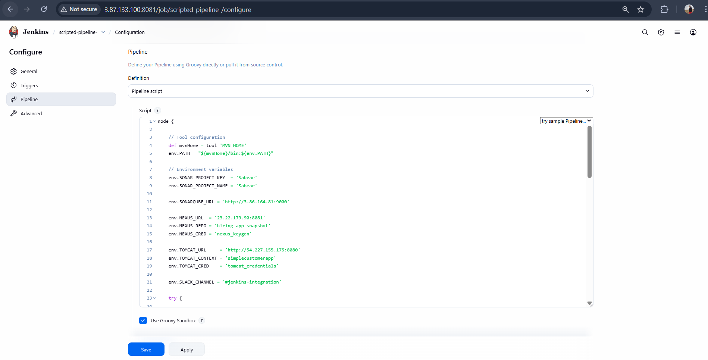
Build was executed successfully
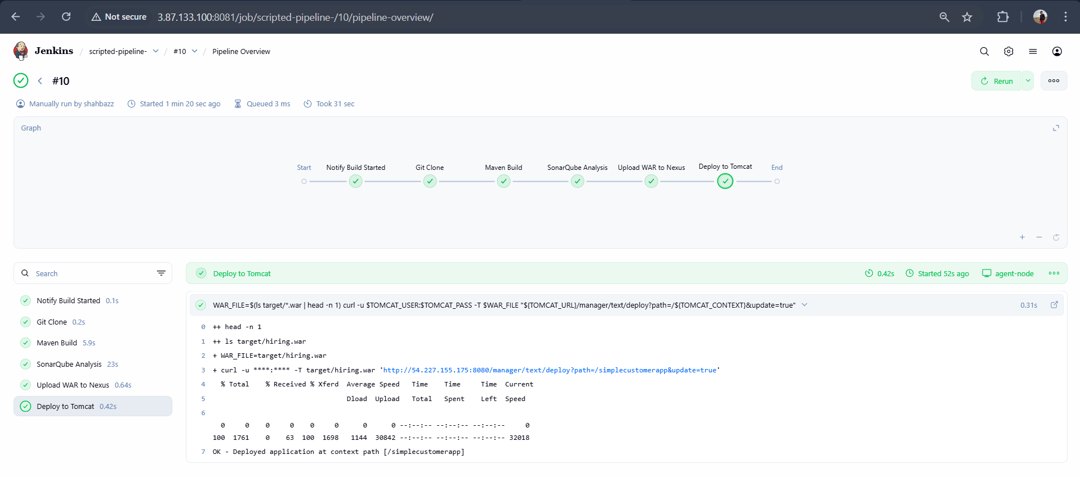
Slack Notification:
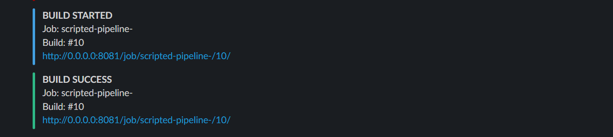

3.Create one multi stage pipeline job
Create a new job for multi stages
Job new Item multi-stage-pipeline
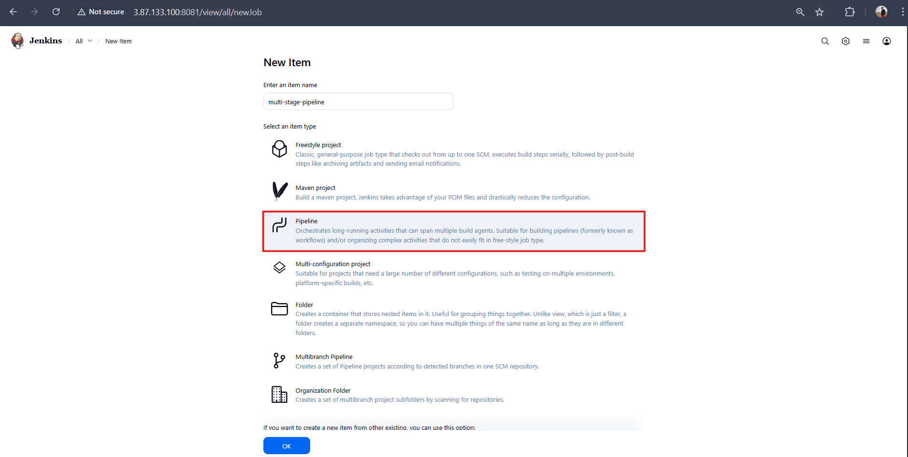
Pipeline which I have used:
node {

def mvnHome = tool 'MVN_HOME'
env.PATH = "${mvnHome}/bin:${env.PATH}"

env.SONAR_PROJECT_KEY = 'Sabear'
env.SONAR_PROJECT_NAME = 'Sabear'
env.SONARQUBE_URL = 'http://3.86.164.81:9000'

env.NEXUS_URL = '23.22.179.90:8081'
env.NEXUS_REPO = 'hiring-app-snapshot'
env.NEXUS_CRED = 'nexus_keygen'

env.TOMCAT_URL = 'http://54.227.155.175:8080'
env.TOMCAT_CONTEXT = 'simplecustomerapp'
env.TOMCAT_CRED = 'tomcat_credentials'

env.SLACK_CHANNEL = '#jenkins-integration'

try {

stage('Notify Build Started') {
slackSend(
channel: env.SLACK_CHANNEL,
color: '#439FE0',
message: "*BUILD STARTED*\nJob: ${env.JOB_NAME}\nBuild: #${env.BUILD_NUMBER}\n${env.BUILD_URL}"
)
}

stage('Git Clone') {
git branch: 'main',
url: 'https://github.com/betawins/hiring-app.git'
}

stage('Maven Build') {
sh 'mvn clean package -DskipTests'
}

stage('SonarQube Analysis') {
timeout(time: 10, unit: 'MINUTES') {
withSonarQubeEnv('sonarqube-server') {
sh '''
mvn org.sonarsource.scanner.maven:sonar-maven-plugin:5.5.0.6356:sonar \
-Dsonar.projectKey=Sabear \
-Dsonar.projectName=Sabear
'''
}
}
}

stage('Upload WAR to Nexus') {
withCredentials([usernamePassword(
credentialsId: env.NEXUS_CRED,
usernameVariable: 'NEXUS_USER',
passwordVariable: 'NEXUS_PASS'
)]) {
sh '''
WAR_FILE=$(ls target/*.war | head -n 1)

curl -u $NEXUS_USER:$NEXUS_PASS \
--upload-file $WAR_FILE \
http://${NEXUS_URL}/repository/${NEXUS_REPO}/com/javahome/hiring/${BUILD_NUMBER}/hiring-${BUILD_NUMBER}.war
'''
}
}

stage('Deploy to Tomcat') {
withCredentials([usernamePassword(
credentialsId: env.TOMCAT_CRED,
usernameVariable: 'TOMCAT_USER',
passwordVariable: 'TOMCAT_PASS'
)]) {
sh '''
WAR_FILE=$(ls target/*.war | head -n 1)

curl -u $TOMCAT_USER:$TOMCAT_PASS \
-T $WAR_FILE \
"${TOMCAT_URL}/manager/text/deploy?path=/${TOMCAT_CONTEXT}&update=true"
'''
}
}

slackSend(
channel: env.SLACK_CHANNEL,
color: 'good',
message: "*BUILD SUCCESS*\nJob: ${env.JOB_NAME}\nBuild: #${env.BUILD_NUMBER}\n${env.BUILD_URL}"
)

} catch (err) {

slackSend(
channel: env.SLACK_CHANNEL,
color: 'danger',
message: "*BUILD FAILED*\nJob: ${env.JOB_NAME}\nBuild: #${env.BUILD_NUMBER}\n${env.BUILD_URL}"
)

throw err
}
}
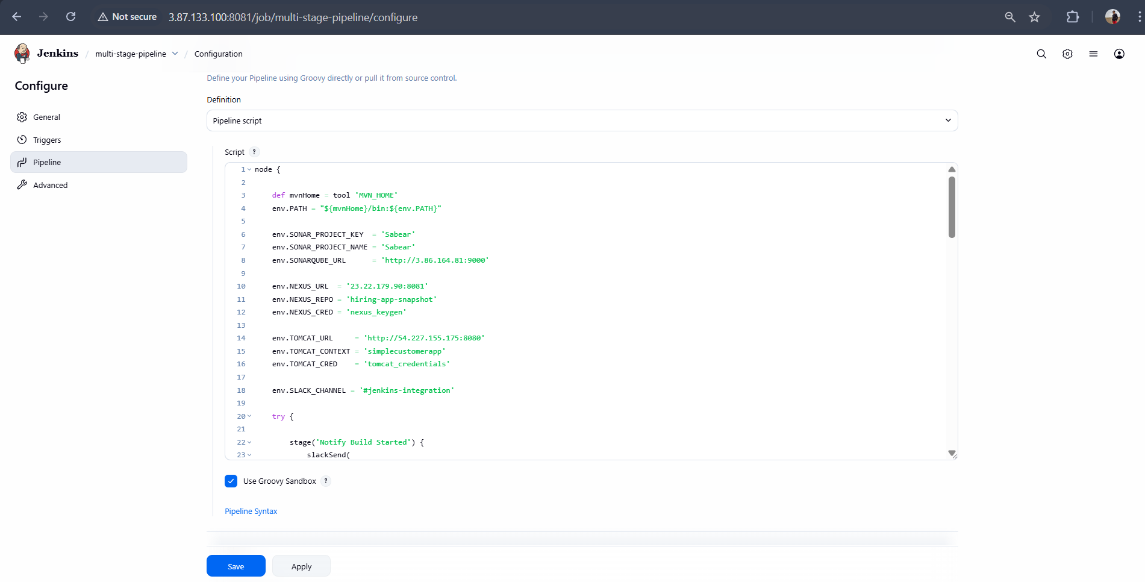
Build was executed successfully

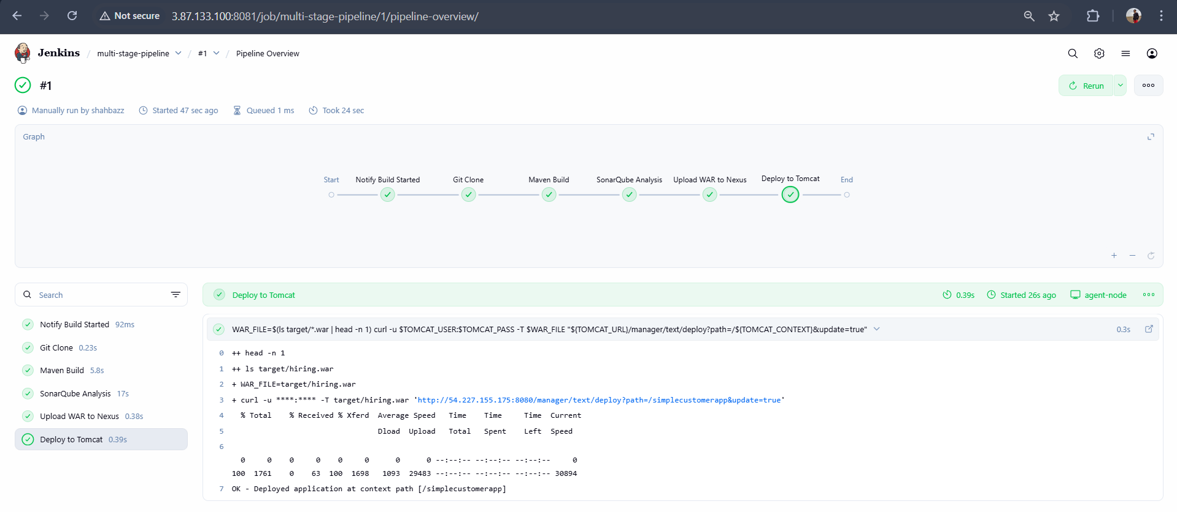
Slack Notification:
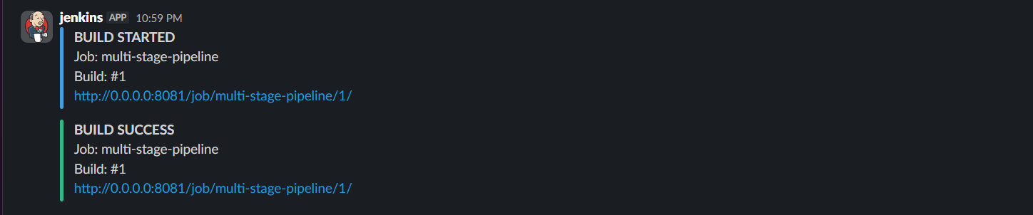

4.Create one parallel stage pipeline job Jenkins Official
Go to dashboard and create a new job for parallel pipeline
Job new Item parallel-stage-pipeline
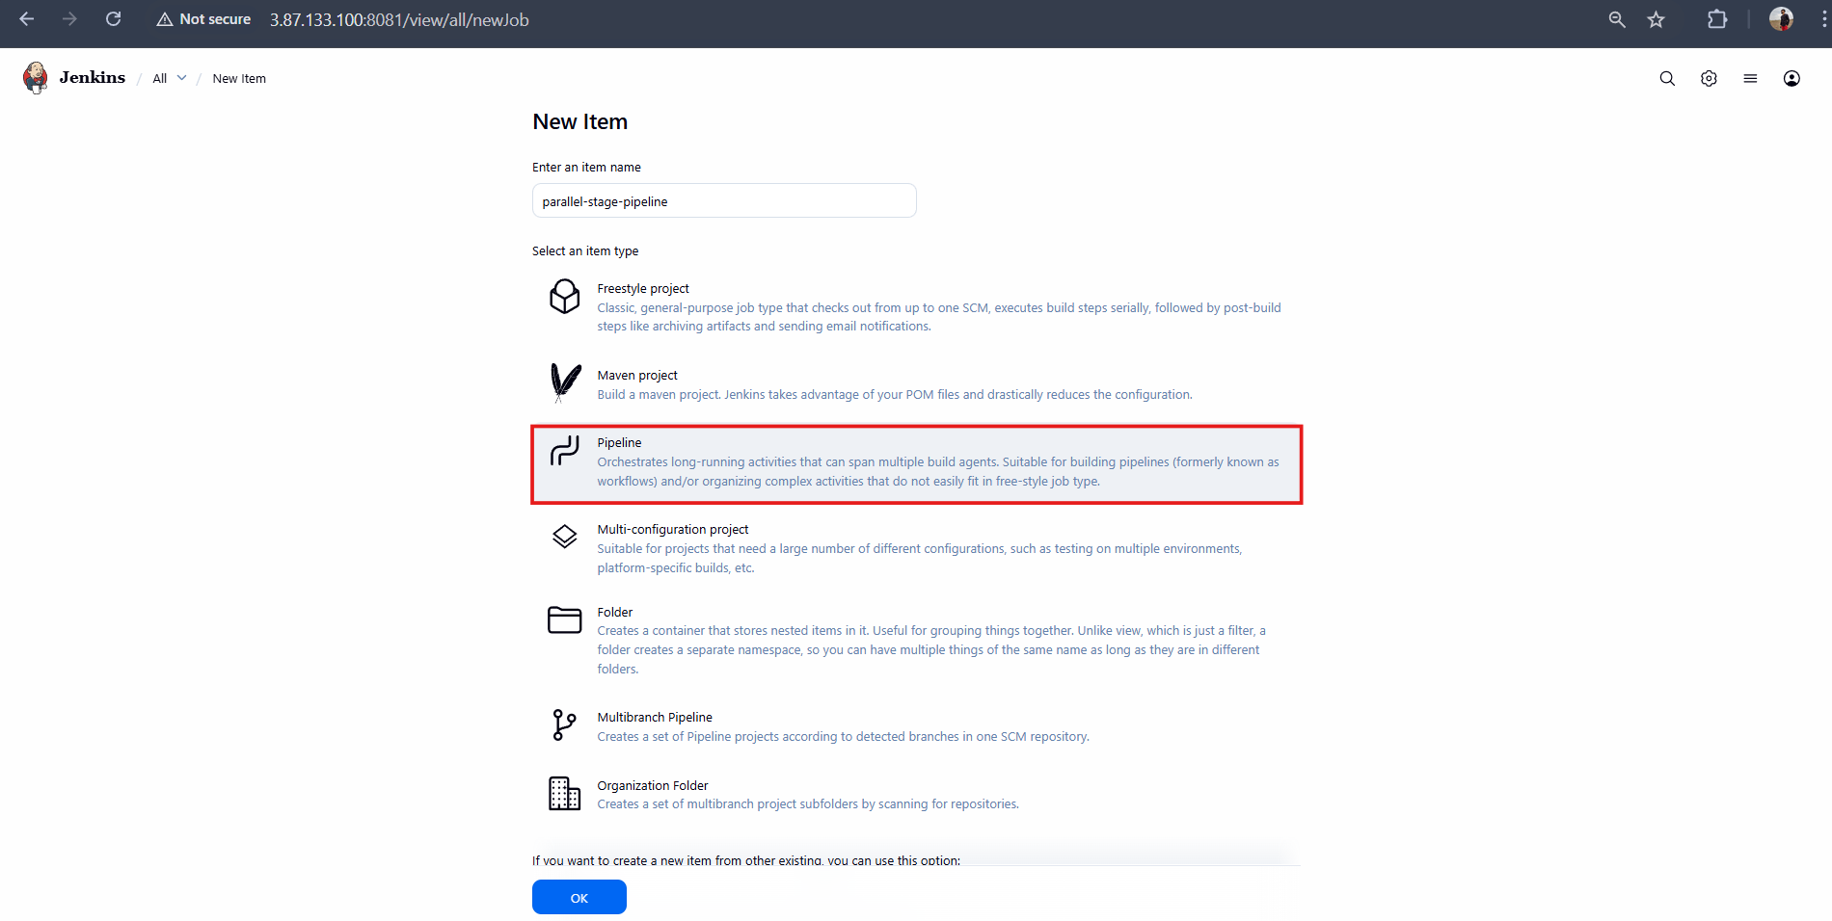
Pipeline which I have used:
pipeline {
agent any

tools {
maven 'MVN_HOME'
}

environment {
SONAR_PROJECT_KEY = 'Sabear'
SONAR_PROJECT_NAME = 'Sabear'

SONARQUBE_URL = 'http://3.86.164.81:9000'

NEXUS_URL = '23.22.179.90:8081'
NEXUS_REPO = 'hiring-app-snapshot'
NEXUS_CRED = 'nexus_keygen'

TOMCAT_URL = 'http://54.227.155.175:8080'
TOMCAT_CONTEXT = 'simplecustomerapp'
TOMCAT_CRED = 'tomcat_credentials'

SLACK_CHANNEL = '#jenkins-integration'
}

stages {

stage('Notify Build Started') {
steps {
slackSend(
channel: "${SLACK_CHANNEL}",
color: '#439FE0',
message: "*BUILD STARTED*\nJob: ${env.JOB_NAME}\nBuild: #${env.BUILD_NUMBER}\n${env.BUILD_URL}"
)
}
}

stage('Git Clone') {
steps {
git branch: 'main',
url: 'https://github.com/betawins/hiring-app.git'
}
}

stage('Maven Build') {
steps {
sh 'mvn clean package -DskipTests'
}
}

stage('SonarQube Analysis') {
options {
timeout(time: 10, unit: 'MINUTES')
}
steps {
withSonarQubeEnv('sonarqube-server') {
sh '''
mvn org.sonarsource.scanner.maven:sonar-maven-plugin:5.5.0.6356:sonar \
-Dsonar.projectKey=Sabear \
-Dsonar.projectName=Sabear
'''
}
}
}

stage('Release & Deploy (Parallel)') {
parallel {

stage('Upload WAR to Nexus') {
steps {
withCredentials([usernamePassword(
credentialsId: "${NEXUS_CRED}",
usernameVariable: 'NEXUS_USER',
passwordVariable: 'NEXUS_PASS'
)]) {
sh '''
WAR_FILE=$(ls target/*.war | head -n 1)

curl -u $NEXUS_USER:$NEXUS_PASS \
--upload-file $WAR_FILE \
http://${NEXUS_URL}/repository/${NEXUS_REPO}/com/javahome/hiring/${BUILD_NUMBER}/hiring-${BUILD_NUMBER}.war
'''
}
}
}

stage('Deploy to Tomcat') {
steps {
withCredentials([usernamePassword(
credentialsId: "${TOMCAT_CRED}",
usernameVariable: 'TOMCAT_USER',
passwordVariable: 'TOMCAT_PASS'
)]) {
sh '''
WAR_FILE=$(ls target/*.war | head -n 1)

curl -u $TOMCAT_USER:$TOMCAT_PASS \
-T $WAR_FILE \
"${TOMCAT_URL}/manager/text/deploy?path=/${TOMCAT_CONTEXT}&update=true"
'''
}
}
}
}
}
}

post {
success {
slackSend(
channel: "${SLACK_CHANNEL}",
color: 'good',
message: "*BUILD SUCCESS*\nJob: ${env.JOB_NAME}\nBuild: #${env.BUILD_NUMBER}\n${env.BUILD_URL}"
)
}

failure {
slackSend(
channel: "${SLACK_CHANNEL}",
color: 'danger',
message: "*BUILD FAILED*\nJob: ${env.JOB_NAME}\nBuild: #${env.BUILD_NUMBER}\n${env.BUILD_URL}"
)
}
}
}

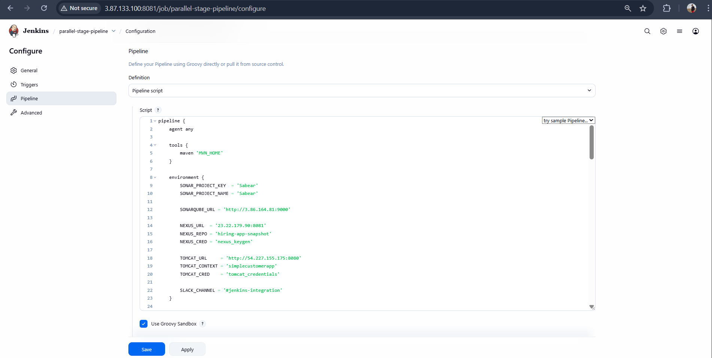
Build was executed successfully
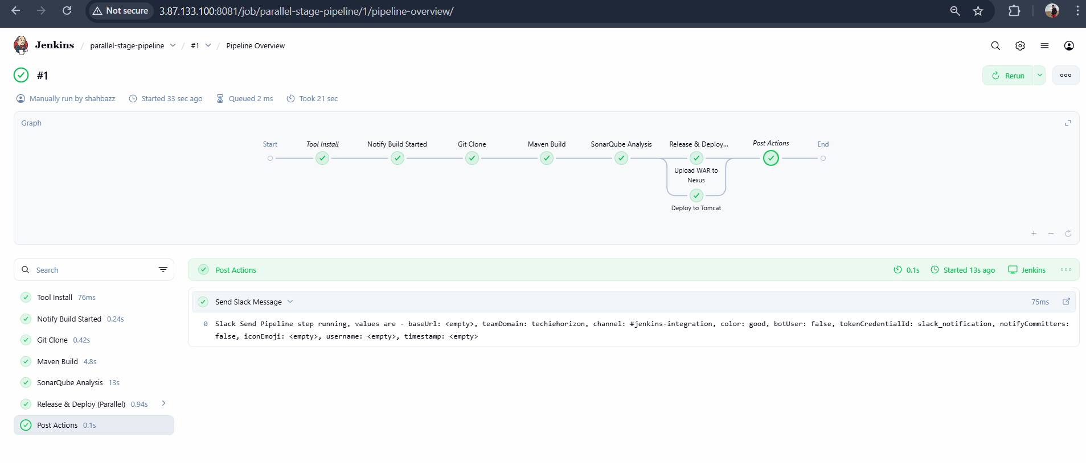
Slack Notification:
